K230063 LAB 11

TASK 1:

INCLUDE Irvine32.inc

.data

.code

main PROC

mov ecx, 0

mov eax, 4

mov ebx, eax

shl eax, 4

add ecx, eax

mov eax, ebx

shl eax, 2

add ecx, eax

mov eax, ebx

add ecx, eax

mov eax, ecx

call WriteDec

exit

main ENDP

END main

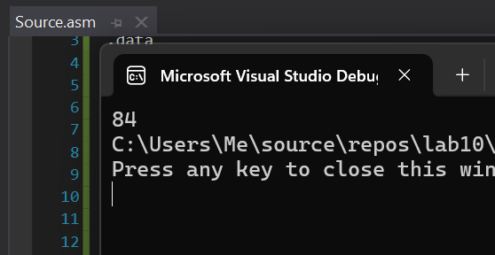

TASK 2:

INCLUDE Irvine32.inc

.data

.code

main PROC

mov eax, 0

mov ax, -128

call WriteBin

shl eax, 16

call crlf

call WriteBin

sar eax, 16

call crlf

call WriteBin

call crlf

call WriteInt

exit

main ENDP

END main

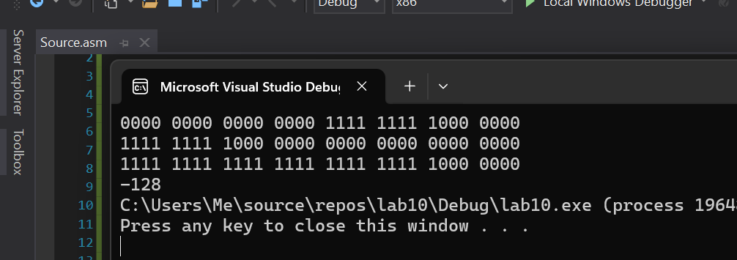

TASK 3:

INCLUDE Irvine32.inc

.data

bMinutes byte ?

.code

main PROC

mov ax, 1111111111111111b

mov bx, ax

shr bx, 5

and bl, 00111111b

mov bMinutes, bl

movzx eax, bl

call WriteBin

exit

main ENDP

END main

TASK 4:

INCLUDE Irvine32.inc

.data

.code

main PROC

mov eax, 10010011b

mov ebx, 01010011b

shr ax, 1

rcr bx, 1

call WriteBin

call crlf

mov ax, bx

call WriteBin

call crlf

call crlf

; With SHRD

mov eax, 10010011b

mov ebx, 01010011b

shrd ax, bx, 1

call WriteBin

call crlf

exit

main ENDP

END main

TASK 5:

INCLUDE Irvine32.inc

.data

val1 dword 10

val2 dword 5

val3 dword 5

temp1 dword ?

temp2 dword ?

msg byte "Val1 = ", 0

.code

main PROC

mov eax, val2

cdq

idiv val3

mov temp1, eax

mov eax, val1

cdq

idiv val2

mov temp2, eax

mov eax, temp1

imul eax, temp2

mov val1, eax

mov edx, offset msg

call WriteString

call WriteDec

exit

main ENDP

END main

TASK 6:

INCLUDE Irvine32.inc

.data

num1 dword 12345678h ; lower

num2 dword 00000001h ; upper

num11 dword 87654321h ; lower

num22 dword 00000002h ; upper

result1 dword ?

result11 dword ?

.code

Extended_Add PROC

mov eax, num1

add eax, num11

mov result1, eax

mov eax, num2

adc eax, num22

mov result11, eax

ret

Extended_Add ENDP

main PROC

call Extended_Add

mov eax, result1 ; lower

call WriteHex

call crlf

mov eax, result11 ; upper

call WriteHex

call crlf

exit

main ENDP

END main

TASK 7:

INCLUDE Irvine32.inc

.data

prompt byte "Enter number : ", 0

primeMsg byte " Prime ", 0

NprimeMsg byte " Not Prime ", 0

num dword 0

.code

IsPrime PROC

mov edx, offset prompt

call WriteString

call ReadDec

cmp eax, 1

je returning

cmp eax, 2

je Primee

mov ecx, eax

mov num, 2

sub ecx, 2

i:

push eax

mov edx, 0

div num

cmp edx, 0

pop eax

jz Not_prime

add num, 1

loop i

Primee:

call WriteDec

mov edx, offset primeMsg

call WriteString

call crlf

jmp looping

Not_prime:

call WriteDec

mov edx, offset NprimeMsg

call WriteString

call crlf

jmp looping

looping:

call IsPrime

returning:

ret

IsPrime ENDP

main PROC

call IsPrime

exit

main ENDP

END main

TASK 8:

TASK 9:

INCLUDE Irvine32.inc

.data

msg BYTE "Result: ", 0

.code

main PROC

mov eax, 14 ; multiplier

mov ebx, 3 ; multiplicand

mov edx, 0

call BitwiseMultiply

exit

main ENDP

BitwiseMultiply PROC

L1:

cmp eax, 0

je donee

test eax, 1

jz shiftt

add edx, ebx

shiftt:

shr eax, 1

shl ebx, 1

jmp L1

donee:

mov eax, edx

mov edx, offset msg

call crlf

call WriteString

call WriteDec

call crlf

ret

BitwiseMultiply ENDP

END main

TASK 10:

INCLUDE Irvine32.inc

.data

str1 byte "Enter the first number: ", 0

str2 byte "Enter the second number: ", 0

str3 byte "GCD of both the numbers is ", 0

.code

GCD PROC

L1:

cmp ebx, 0

jbe endd

cdq

div ebx

mov eax, ebx

mov ebx, edx

JMP L1

endd:

ret

GCD ENDP

main PROC

call crlf

mov edx, offset str1

call WriteString

call ReadDec

mov ebx, eax

mov edx, offset str2

call WriteString

call ReadDec

mov edx, eax

mov eax, ebx

mov ebx, edx

call GCD

mov edx, offset str3

call WriteString

call WriteDec

call crlf

exit

main ENDP

END main

TASK 11:

INCLUDE Irvine32.inc

DECIMAL_OFFSET equ 5

.data

decimal_one BYTE "100123456789765", 0

.code

main PROC

call WriteScaled

exit

main ENDP

WriteScaled PROC

mov esi, OFFSET decimal_one

mov ecx, 0

mov edi, esi

mov edx, 0

getLength:

mov al, [edi]

inc edi

inc edx

cmp al, 0

jne getLength

sub edx, DECIMAL_OFFSET

printt:

mov al, [esi]

call WriteChar

inc esi

inc ecx

cmp ecx, edx

jne skippingDec

mov al, '.'

call WriteChar

skippingDec:

cmp BYTE PTR [esi], 0

jne printt

ret

WriteScaled ENDP

exit

END main